Scenario in Text

No.1 Add an event in the calendar

Photo:

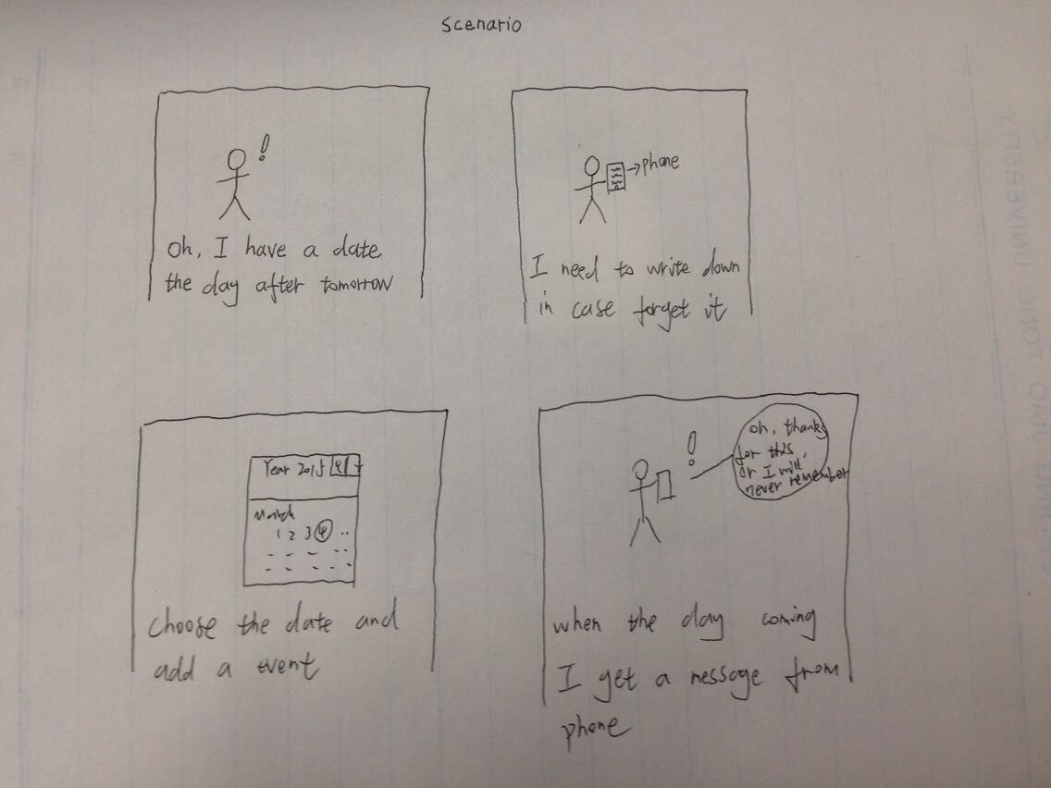

Before:

I have something to do in a future day, but I do not think I can remember it just depend on my memory. So, I need to write it down on my phone in this app.

During:

So that when the day before that day, my phone will tell me that tomorrow I have something to do.

After:

When the day come, the phone will remind me again. So, I will never forget that thing.

Use Case1—Add an Event

Precondition-none

Description-The user finds the date, and presses the “Add” button. The text filed appears and allow you to write something down.

Post-condition-The context will save.

Exception-The context is null, then dialog box prompts user to enter or give up this add.

Use Case2—Set Remind

Precondition-The user adds an event.

Description-The user sets remind type and frequency.

Post-condition-The phone will set this and remind user when the day come.

Exception- the same as in Use Case1.

Use Case3—Check and Modify

Precondition-The user adds an event and sets remind.

Description-The user can check the event and modify it.

Post-condition-The event will be modified and set up again.

Exception-If the user forget press “save” button the app will not allow the modification.